How To – Divide By Current Period Report
There are times when you would like to do a calculation using the period the report was run for. In this example the need is to divide the year to date Headcount # by the period #.

Row Format Settings:
First, you will need to pull in the head count balance.
In this example the Headcount balance is being stored in a separate “Book Code” than the normal balances. The “Book Code” is named “Head_Count”. In order to pull a balance from a book code that does not match what is setup in the column layout (in this case “Actual”) we need to use a full account mask and row modifier to specify the book code. (E.G.: “ 5000-1100-001, /B:Head_Count”).
Note: Row modifiers are beyond the scope of this document. Please refer to the Online Help for more information on this topic.
The calculation specifies to pull the head count YTD balance and the period number from specific rows and columns. (E.G.: B310 & O310).
Note: You can make the head count row non-printing and the calculation will still work correctly.

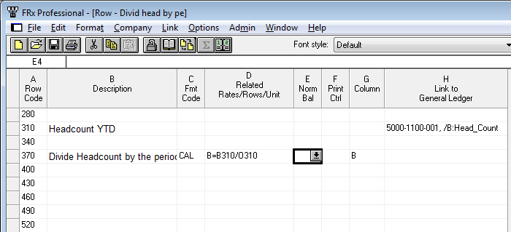

Column Layout Settings:
The column layout is where the setup gets tricky.
You need to create 13 new columns. (Or, more if your calendar supports more periods.) Each period needs its own CALC column, and a final calc column for a placeholder for the data.
Each period calc column should be setup with the following information (refer to screenshot):
Type = CALC
Period Code = the period number (1-12)
Calc Formula= this also should be the period number (1-12)
Column Width= 2
Special Format Mask= 0
Print Control= P=B
The final Calc formula should have the following information (again, refer to the screenshot):
Type= CALC
Calc Formula= C TO N
Special Format Mask= 0
Print Control= NP
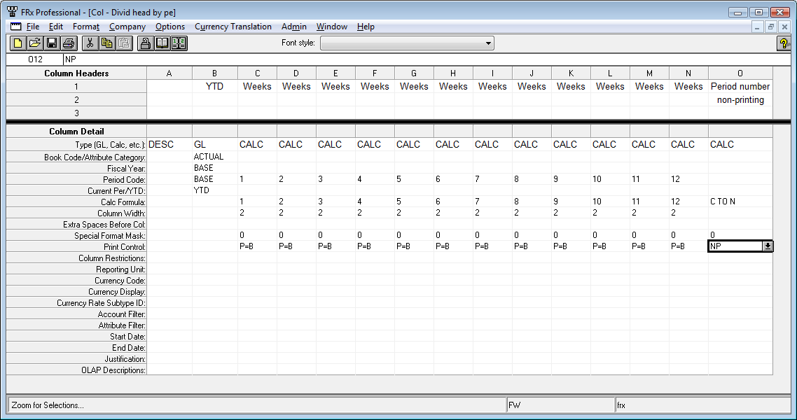

Catalog Settings:
Set the Calculation Priority to “Calculate Columns First”.
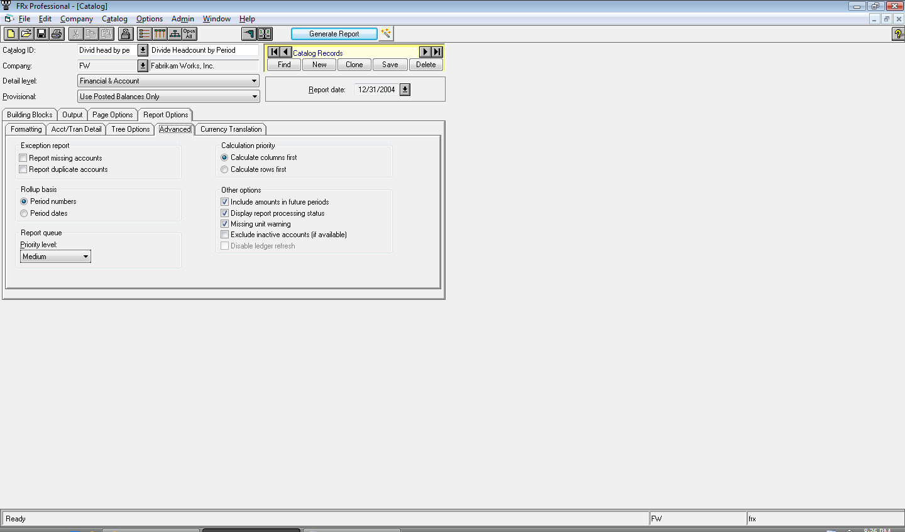

Final Report:
Set
